The Cavalier King Charles Spaniel Club
of Northeastern New York
is pleased to announce the return of the
Straw Hat Specialty on Friday August 12th and Saturday August 13th, 2022

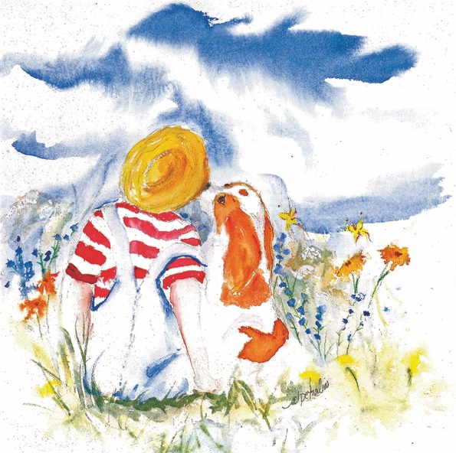
It is the 'August Place' to be and it is all happening at
The Saratoga County Fairgrounds in Ballston Spa, New York 12020
Rain or shine we are undercover in the Bovine Pavilion!
Judges
Friday - David Frei
Saturday - Michael Forte
Sweepstakes - Karen Sage, Dreamvale Cavaliers

🎉The fun Begins🎉
Thursday, August 11th Evening: Welcome Party – 5:30pm
Wine, Craft Beer and Cheese Tasting🍷🍺🧀
-Compliments of KARLEE GRAY STONE CAVALIERS-

Friday, August 12th Evening: Pizza Party 🍕– 6:00pm
Join us for a complimentary dinner with pizza and soft drinks!
-Compliments of The Cavalier King Charles Spaniel Club of Northeastern New York-

After dinner we will host a pet cavalier dog show with your cavalier(s).
Ribbons and prizes to all cavaliers that participate!

Please RSVP by August 5th to Amy Cox: ac4dogs@nycap.rr.com

Silent auction – Thursday, Friday, & Saturday and will close at the banquet Saturday evening.
50/50 - Winning 50/50 tickets will be pulled during the banquet

All meal options are available by Reservation only please!
The Premium List will have a Reservation Form with Payment Options and instructions.
Friday and Saturday Lunch: Box lunch$7.50 each
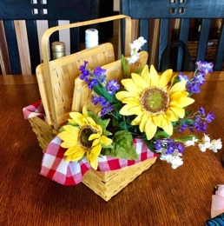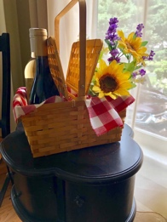
Saturday Evening – 6:00pm - Country Picnic Dinner
Menu: (may vary) Oven Roasted Chicken, Beef Brisket, Roasted Vegetable Medley, Roasted Sweet & White Potatoes, Cole Slaw, Corn on The Cob, Watermelon, Tuxedo Mousse Cake- $40 Per Person
For more information email Laura Calabrese: laura.l.calabrese@gmail.com

Following the Banquet dinner on Saturday evening - LIVE Auction with David Frei
(known for ‘The Voice of Westminster’) as our Auctioneer

-The Fairgrounds requires a proof of current rabies vaccination! PLEASE bring a copy in case you are asked-
-Please no flexi or similar style leads-
Hope to see you there!

