2023 Calendars are here!
All proceeds go directly to benefit the
ACKCSC Charitable Health Trust and the ACKCS Rescue Trust.

ORDER YOURS TODAY!

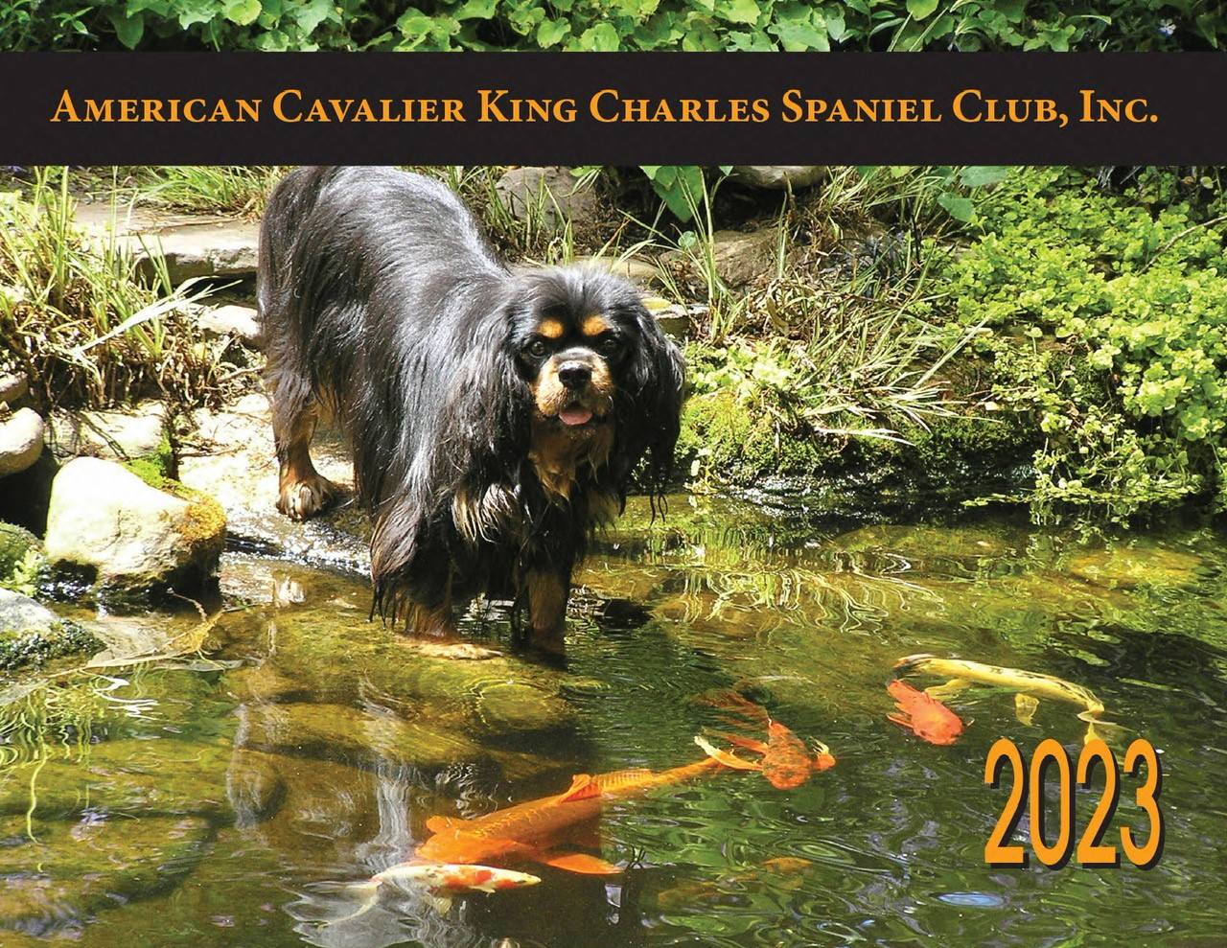 | 